2018 SWISH T-Shirt Pre-order Form
Fill out the form below to pre-order your 2018 SWISH shirts! Pre-orders must be paid prior to pick up via credit card or check. You may pick up your event gear prior to March 9th, 2018 at the Helena Chamber office (225 N. Cruse Ave, Ste. A) or at C.R. Anderson on Saturday, March 10th. Pre-order shirts will not be shipped. All sales are final. No refunds. Please contact Alana at alanac@helenachamber.com or 406-442-4120 for more information.

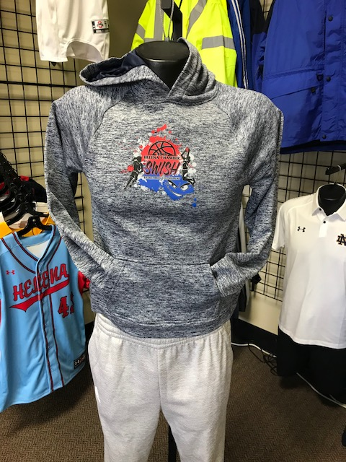
YOUTH Hoodies - $35

YOUTH: ____ (S) ____ (M) ____ (L)

ADULT Hoodies - $35

ADULT: ____ (S) ____ (M) ____ (L) ____ (XL)

Quarter Zip - $ 40
LIMITED QUANTITY!

ADULT: ____ (S) ____ (M) ____ (L) ____ (XL)
YOUTH: ____ (S) ____ (M) ____ (L)
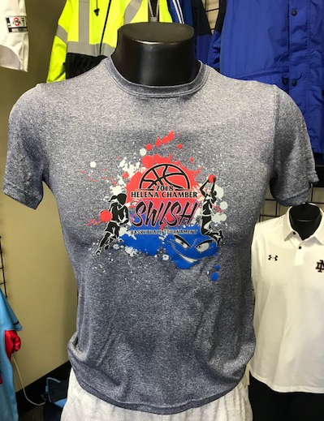

T-shirt - $25
ADULT: ____ (S) ____ (M) ____ (L) ____ (XL)
YOUTH: ____ (S) ____ (M) ____ (L)

Your Name: _______________________________
E-mail Address: ____________________________
Phone Number: ___________________________
CREDIT CARD (circle one): VISA AMEX DISCOVER MASTERCARD
Credit Card # __________________________________ EXP Date: ___________
Signature___________________________________
CHECK PAYMENTS:
Make checks payable to:
The Helena Area Chamber of Commerce
ATTN: Alana
225 N. Cruse Ave
Helena, MT 59601
E-MAIL FORM/CREDIT CARD PAYMENTS: Alana Cunningham, alanac@helenachamber.com

